

Agentic AI & Sports Intelligence
Subtitle
Diogo Domingues Godinho

Master Thesis
presented as partial requirement for obtaining a Master’s Degree in Information Management

NOVA Information Management School
Instituto Superior de Estatística e Gestão de Informação
Universidade Nova de Lisboa

NOVA Information Management School
Instituto Superior de Estatística e Gestão de Informação
Universidade Nova de Lisboa

TITLE
Subtitle

by
Diogo Domingues Godinho

Master Thesis presented as partial requirement for obtaining the Master’s degree in Information Management, with a specialization in ………

Supervised by
Supervisor’s name, academic title (PhD; MSc…), Academic institution or School affiliation of the supervisor
EXAMPLE: Miguel de Castro Neto, PhD, NOVA Information Management School

Month, Year

Statement of Integrity
I hereby declare having conducted this academic work with integrity. I confirm that I have not used plagiarism, any form of undue use of information or falsification of results along the process leading to its elaboration. I further declare that I have fully acknowledged the Rules of Conduct and Code of Honor from the NOVA Information Management School.
[place, date]
Just type your name, not your signature

Dedication (OPTIONAL)

Just if you want to dedicate your work to someone dear to you or to someone that inspired you in your life. Here is not the place for acknowledge, it is a distinct honour to someone, although it is optional.

Acknowledgements (OPTIONAL)

This is an optional page, however it is always very important to acknowledge those who made this possible, like family, friends, colleagues, professors, staff, University, and those who anonymously participated in the data collection phase, for example.

Abstract
This work presents an innovative approach to injury forecasting, performance projection, and athlete evaluation in sports (particularly the NFL) by integrating Agentic Artificial Intelligence, Generative Artificial Intelligence, and blockchain technology. The objective is to develop a system capable of processing historical and real-time data to deliver accurate, accessible, and scalable insights, particularly for teams with limited resources. The methodology combines three main datasets: historical yearly player statistics, weekly performance data from the 2020 season, and daily biometric metrics from a former player, including heart rate, sleep patterns, and fatigue. The proposed system employs Agentic AI to automate data collection, analysis, and cross-referencing, while Generative AI transforms results into natural-language reports tailored for coaches, analysts, and medical teams. Blockchain ensures the integrity, traceability, and transparency of athlete records, enabling the creation of an “Athlete Passport” consolidating attributes, performance history, and health information. Designed to operate continuously, the model stores data for longitudinal analysis and generates performance indices that support training load management, injury prevention, and performance optimization. By providing an automated and user-friendly workflow capable of generating alerts and objective comparisons, this research aims to demonstrate how integrating these technologies can enhance the efficiency, accuracy, and accessibility of sports analytics processes in professional and semi-professional contexts, paving the way for broader adoption of predictive analysis in daily team operations.

Keywords
Keyword 1; Keyword 2; Keyword 3; Keyword 4; Keyword 5 (always separated by ; )

Sustainable Development Goals (SDG):


Table of Contents
Statement of Integrity ii
Dedication (OPTIONAL) iii
Acknowledgements (OPTIONAL) iv
Abstract v
List of Figures viii
List of Tables ix
List of Abbreviations and Acronyms x
0. Formatting guidelines [DELETE THIS CHAPTER] xi
1. Introduction 1
2. Literature review 4
2.1. Sport Management 4
2.1.1. Concepts 4
2.1.2. Challenges and Opportunities 4
2.1.3. The use of intelligent technologies in Sport Management 4
2.2. Agentic AI 4
2.2.1. Overview 4
2.2.2. Approaches and Platforms 4
2.2.3. Agentic AI in Sports 5
2.3. Related Work 5
3. Methodology 6
4. Empirical Study 7
5. Results and Discussion 8
6. Conclusions and Future Research 9
Bibliographical References [This title should not be numbered] 10
Appendix A (optional, appendixes should have letters instead of numbers) 11
Annex A (optional) 12

List of Figures
Figure 0.1 – Illustrative figure xv

List of Tables
Table 0.1 – Illustrative table xv

List of Abbreviations and Acronyms
Acronym A Explanation of acronym A Explanation of acronym A Explanation of acronym A Explanation of acronym A Explanation of acronym A Explanation of acronym A
Acronym B Explanation of acronym B Explanation of acronym B Explanation of acronym B Explanation of acronym B Explanation of acronym B Explanation of acronym B

0. Formatting guidelines [DELETE THIS CHAPTER]
Your work must not contain chapter number 0. You must delete this chapter from the document of your final work.
This Word file provides a "standard" proposal structure and all the styles necessary for adequately formatting the Master Thesis/Work Project of NOVA Information Management School of Universidade Nova de Lisboa.
Students must use the APA style standard for bibliographical references; this standard also applies to the references format and respective referencing forms throughout the text.
In this file you will also find a step-by-step guide for formatting the text, figures and tables throughout your work. We advise you to always keep a copy of this template for future reference while you work on your thesis.

In case of other text format or bibliographic references doubts, contact the Library and Documentation Services for help.
- Pagination
For different styles of pagination, it’s necessary to add a Page Break before the page we want to add the pagination. For that, go to the Insert tab and select Page Break:

If the previous option creates a blank page, go to Insert tab and click with mouse’s right button on Pages to Customized the Ribbon:

On the left side of the dialog box, select the option Insert Page & Section Breaks:
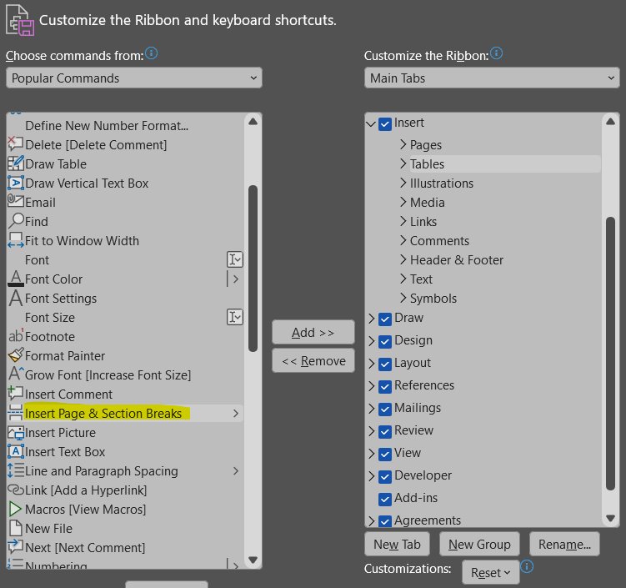
On the right side, select Pages and create a New Group (you may rename it as you wish; in this case, we called it Breaks). Then click Add:
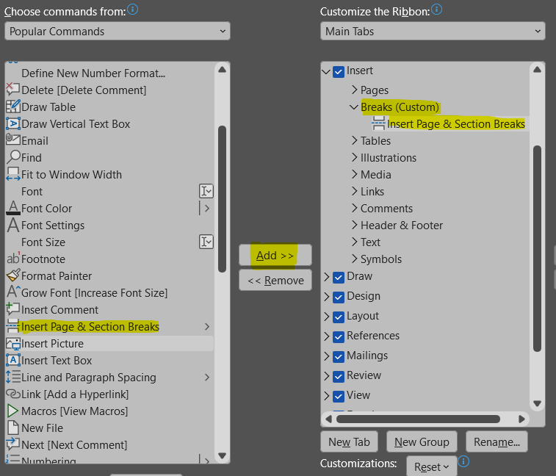
On the Insert Tab, you will find the new ribbon Breaks. Select the option Continuous to create a section break without adding a new blank page:

To insert the pagination, select the option Page Number, and choose Format Page Numbers:


Select the Number format (i, ii, iii, … for the preliminary pages and 1, 2, 3, … for the body of the text):
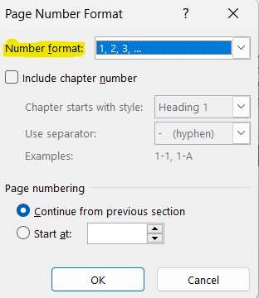

- Labels of figures and tables
To insert a figure label, go to the References tab and select the option Insert Caption:
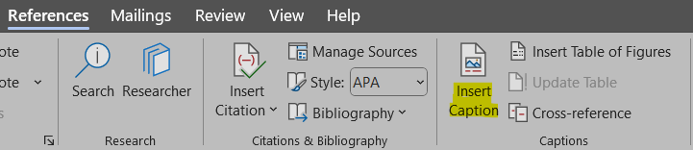
Select the option Numbering:
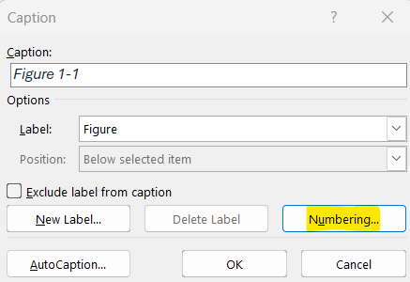
Choose Format 1, 2, 3, ... and select the box in the option Include chapter number (it is possible to select the Heading of each chapter and select a hyphen or a dot as separator between numbers):
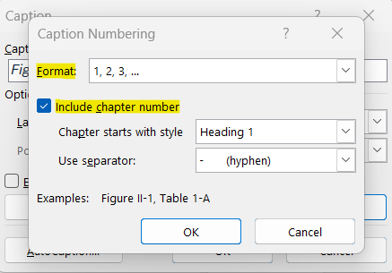

To insert a table label, go to the References tab and select the option Insert Caption:
In Label, select the option Table, then select Numbering:
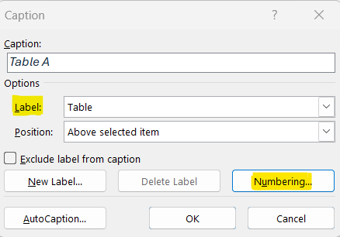
Choose Format 1, 2, 3, ... and select the box in the option Include chapter number (it is possible to select the Heading of each chapter and select a hyphen or a dot as separator between numbers):
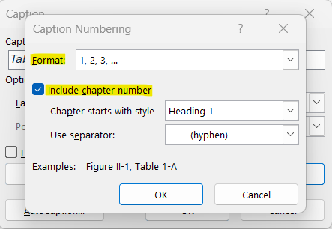

Here is an example of a figure label:

Figure 0.1 – Illustrative figure
Note that figure labels should be included after the figure. The alignment of the label should also be centered, instead of aligned to the left. Make sure the figure’s alignment is also centered, for a more cohesive layout throughout the work.
Here you can find an example of a table label:

Table 0.1 – Illustrative table
Title | Title
Text | Number
Text | Number
Text | Number

The student can freely choose the table design, as long as it remains consistent throughout the document. Note that table labels should always be included before the table. The alignment of both the table and the label should be centered throughout the work.
- List of Figures and List of Tables
To insert List of Figures, go the References tab and select the option Insert Table of Figures:
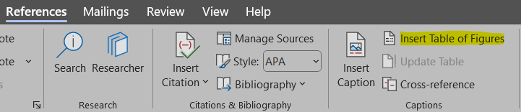
Verify that the Caption label selected is Figure:
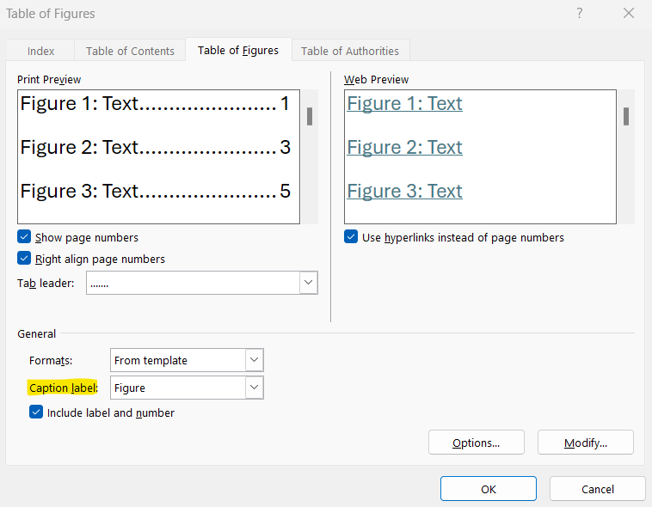

To insert List of Tables, go to the References tab and select the option Insert Table of Figures:

Verify that the Caption label selected is Table:
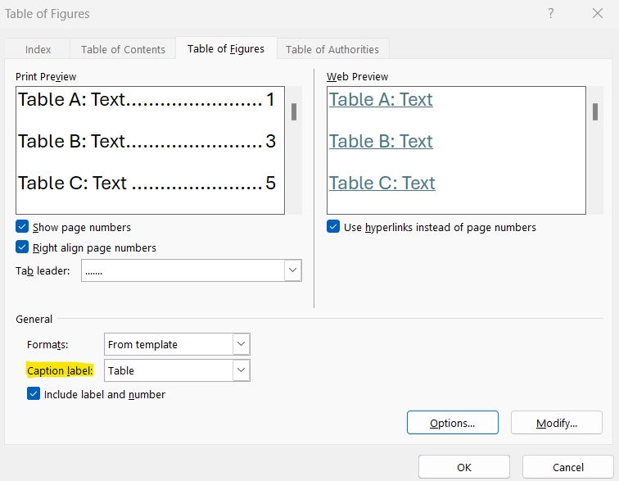
- Equations
We advise the identification of the equations present throughout the work to be done on the right:
${\left(x+a\right)}^{n}=\sum_{k=0}^{n}{\left({n \atop k}\right)x^{k}a^{n-k}}$ (0.1)

You can follow the chapter numeration, just like the figures and tables, or you can start with (1).
- Computer coding/Algorithms
For computing code, algorithms or other, it should appear with the label before the code framing, as the following example.
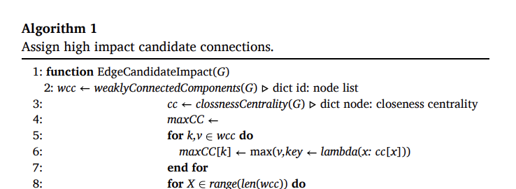
- Bibliographical references
Use APA Style for the entire document. Don’t forget to organize your bibliographical references alphabetically.
We suggest that students use a reference manager system (Zotero, Mendeley, EndNote).
Please review the APA style guide at: https://apastyle.apa.org/style-grammar-guidelines/references/examples
Example:
Author, A. A., Author, B. B., & Author, C. C. (Year). Title of article. Title of Periodical, volume number (issue number), pages. DOI or permanent link.

Here’s a references list with examples of different types of materials:

Areed, S., Alqaryouti, O., Siyam, B., & Shaalan, K. (2020). Aspect-Based Sentiment Analysis for Arabic Government Reviews. In Abd Elaziz, M., Al-qaness, M., Ewees, A., Dahou, A. (Eds.), Recent Advances in NLP: The Case of Arabic Language. Studies in Computational Intelligence (vol. 874, pp. 143–162). Springer. https://doi.org/10.1007/978-3-030-34614-0_8 [book chapter example]

Cook, J. (2024, June 21). Data To Decisions With ChatGPT: 5 Prompts To Analyze Business Metrics. Forbes. https://www.forbes.com/sites/jodiecook/2024/06/21/data-to-decisions-with-chatgpt-5-prompts-to-analyze-business-metrics/ [Website example]

Ercan, Ö., & Kabakçı, A. C. (2019). Subliminal Advertising Applications in Sport: Neuromarketing. International Journal of Sport Culture and Science, 7(1), 41-50. https://dergipark.org.tr/en/pub/intjscs/issue/45916/582724#article_cite [article example]

Krishen, A. S., Dwivedi, Y. K., Bindu, N., & Kumar, K. S. (2021). A broad overview of interactive digital marketing: A bibliometric network analysis. Journal of Business Research, 131, 183–195. https://doi.org/10.1016/j.jbusres.2021.03.061 [article example]

Milakovich, M. E. (2021). Digital Governance: Applying Advanced Technologies to Improve Public Service (2nd ed.). Routledge. https://doi.org/10.4324/9781003215875 [Book example]

Neves, J. P. P. C. (2021). Energy-efficient heating appliance behavior change: The role of green self-identity [Master's thesis, NOVA Information Management School]. RUN Repositório Universidade Nova. http://hdl.handle.net/10362/116182 [Master Thesis example]
Neves, M. F. S. T. (2024). Open Data as a Catalyst for the Evolution of Smart Cities [Doctoral dissertation, NOVA Information Management School]. RUN Repositório Universidade Nova. http://hdl.handle.net/10362/169801 [Doctoral Thesis example]

Redmon, J., Divvala, S., Girshick, R., & Farhadi, A. (2016). You only look once: Unified, real- time object detection. 2016 IEEE Conference on Computer Vision and Pattern Recognition (CVPR), 779–788. https://doi.org/10.1109/CVPR.2016.91 [Conference proceedings example]

- Appendixes’ Figures and Tables labels
To insert Figure and Table labels, start by inserting a Continuous Section Break in the previous page, on the Insert tab:

To insert a figure or table label, go to the References tab and select the option Insert Caption:
Select the option New Label:
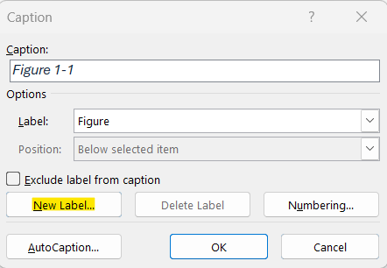

Create the new label with the indication of the Annex to which it belongs to – Figure A., Figure B., … or Table A., Table B, ...:
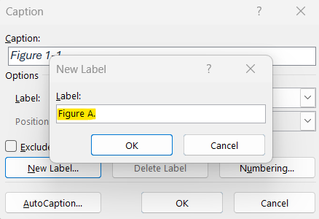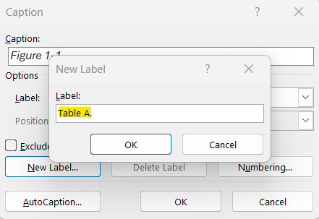

Introduction
Predicting injury risk in sports is a well-established goal in modern sports medicine, as it is critical for preventing injuries, optimizing athletic performance, and improving recovery strategies (Edouard et al., 2024). By accurately anticipating injury risks, teams can design individualized training and rehabilitation programs that help athletes avoid injury and recover more efficiently when injuries do occur (Vincent et al., 2022). This shift from reactive treatment to proactive prevention marks a significant advancement in sports health management (Fagher et al., 2019).

However, traditional prediction methods face persistent challenges, including variability between athletes, biological differences, and the complexity of modeling multiple interacting risk factors (Mausehund & Krosshaug, 2024). Data-related issues – such as inconsistencies in reporting, limitations in availability, and quality concerns – further complicate prediction accuracy (Nassis et al., 2022). The constantly changing nature of an athlete’s physiological state compounds these difficulties, as conventional models often lack the ability to capture real-time dynamics (Rossi et al., 2018).

This project focuses particularly on defensive backs (cornerbacks & safeties) for injury probability analysis and later, skill position players (wide receivers & running backs) for performance forecasting. These athletes are regularly exposed to high-speed, non-contact stresses, making them more susceptible to injuries such as ACL tears and hamstring strains. Despite this elevated risk, there are few widely accessible systems capable of translating week-to-week performance data into early-warning injury alerts or objective fatigue scores (Halson, 2014; Haller et al., 2022).

Building on this injury-centered analysis, the study also incorporates performance forecasting and market valuation by leveraging historical player data from previous seasons. This information will be used to define an overall performance index (explained in a subsequent chapter), which enables more precise comparisons across prior player seasons and supports the identification of historical trends through performance data.

This dual focus gains further relevance when considering that in elite-level sports such as the NFL, vast amounts of performance, workload, and injury history data are collected. However, much of this information remains underutilized in predictive decision-making processes (Lindsey, 2016), a gap that can be addressed using low-code and no-code AI automations coupled with accessible user interfaces.

AI-driven approaches address these shortcomings by integrating diverse data sources, including wearable sensor outputs, biomechanical assessments, performance metrics, and psychological indicators, to construct individualized athlete profiles (Topol, 2018). Beyond enhancing prediction accuracy, AI systems can deliver real-time monitoring and feedback, continuously tracking athlete condition during training or competition, and alerting coaches or medical staff to potential risks before they escalate (Rossi et al., 2018). Moreover, AI enables longitudinal tracking of players’ progress and performance across seasons.

This framework has potential applicability across both elite and lower levels of competition, as well as in a variety of sports contexts. At lower competition levels, analytics resources are even scarcer. Many teams operate without a dedicated analytics department or routine player monitoring processes. Yet, evidence shows that data analytics can enhance performance and support more informed decision-making (Davis et al., 2024; Andersen, 2024). This underlines the importance of developing AI-driven frameworks that remain scalable, practical, and accessible across all tiers of sport.

This project presents a comprehensive analysis of the transformative role of artificial intelligence (AI) in assessing injury probabilities and preventing sports injuries, projecting player performance, and facilitating objective athlete evaluation by leveraging historical performance data as a comparative baseline. The project further explores the integration of Agentic AI for intelligent automation and tooling integration, Generative AI for narrative, tailored and insightful reporting, and blockchain for secure athlete record-keeping. The central aim is to understand how to harness these technologies to produce data-driven insights in controlled, practical conditions, leveraging historical datasets as the foundation for predictions.

Thus, the presented approach aims to address this gap by proposing a system that can be seamlessly integrated into a team’s existing workflow, even in resource-constrained environments, without disrupting daily schedules. The intended contribution is not to replace human expertise but to complement it, embedding analysis and data-driven decisions into everyday operations to support training, player health, and game preparation.

The primary goal, more precisely, is to design and validate a methodology that leverages Agentic AI and Generative AI to automate weekly performance analyses, enable continuous injury monitoring through real-time alerts, and generate actionable insights into NFL players’ health status, performance potential, and future market valuation.

To achieve this overarching objective, the following intermediate objectives were established:
- Conduct a comprehensive literature review on Agentic AI and its applications within sports management
- Examine the conceptual foundations of blockchain technology to evaluate its applicability for maintaining secure and transparent player data logs within an Athlete Management Platform
- Collect relevant information and historical datasets to support predictive modeling and insight generation
- Develop a centralized platform to integrate AI tools and present AI-generated reports.
- Design a structured methodology for combining Agentic and Generative AI through automated workflows and tooling integration
- Create templates and tailored prompts for generating detailed, domain-specific reports and insights
- Implement a prototype demonstrating the functional workflow and report generation within the centralized platform
- Validate the prototype against defined benchmarks and use cases

The proposed framework uses Agentic AI to automate the detection of patterns and variations in health and performance data, retrieving relevant historical information (using player records – almost as a “Knowledge Base”) for analysis. Generative AI then translates these findings into accessible, natural-language reports for coaches, analysts, and medical staff. Complementarily, Blockchain technology is expected to ensure data transparency, integrity, and traceability (Kashyap & Chowdhury, 2024), enabling the creation of a universal digital Athlete Passport that securely stores player attributes, historical performance, and medical records.

As a result, this project seeks to demonstrate, academically, how Agentic AI (workflow logic combined with tool integration), Generative AI (summarization and synthesis), and Blockchain (secure logging and historical data ownership) can be integrated into a practical, modular, and transparent system for sports applications, thereby bridging the gap by offering a scalable and applicable solution for organizations lacking extensive AI and analytics expertise or infrastructure.

Furthermore, the incorporation of real and already in place metrics such as NFL PPR Fantasy Points ratings, as an external validation layer, offers a novel methodological contribution, providing an objective benchmark grounded in real-time scouting intelligence and a quantitative baseline for both player-to-player comparisons and overall team performance evaluation, is expected to enhance the final output.

This project, hopefully, will prove how integration of Agentic AI, Generative AI, and blockchain-based athlete records can improve efficiency, autonomy, and accessibility of custom-made reports for injury analysis and likeliness, performance projection, and player evaluation in professional and semi-professional sports contributing to the state of the art, adding value for further scientific investigations on related topics.

Literature review
This literature review serves as a foundation for the thesis by synthesizing research at the intersection of technology, sports management, and artificial intelligence. It first considers key aspects of sports management, emphasizing injury prevention and how emerging technologies would affect decision-making. It then addresses data-driven methodologies and artificial intelligence, highlighting Agentic AI in tooling and automation and Generative AI in tailored and analytical reporting, highlighting their potential applications in sport. It then addresses the conceptual foundations of blockchain technology as a method of secure and transparent athlete data management. The sections that follow synthesize established contributions and emerging directions, identifying key applications relevant to our artifact modelling while highlighting gaps that remain unresolved, with the aim of avoiding known errors in the scope of sports technology, positioning the research within the trajectory of AI innovation in sport.

Sports Management and Technology in Sports
Sport management is broadly defined as the field of business concerned with sports and recreation (Blanchette, 2022). The field encompasses activities such as planning, organizing, budgeting, controlling, directing, and evaluating various organizations within the sports domain. Over the years, its scope has expanded beyond the traditional administrative functions, now including sports marketing, analytics, sponsorship, and facility management (Belzer, 2014). Essentially, sports involve competition that has strategy and often requires teamwork to win. The level at which one practices sports can either be recreational, competitive, or professional, with a rare category of elite athletes who pursue sports as a full-time job (Pressler & Niebauer, 2020). This thesis focuses primarily on the professional level, where data is more accessible, but also considers implications for broader contexts where professional infrastructure may not exist, highlighting its applicability and potential impact for lower-level teams.

Technology as an Enabler
The growth of sport management has coincided with an increasing reliance on technology as a performance and organizational enabler. “Technology in sports” encompasses tools such as wearables, GPS tracking, video and performance analysis systems, athlete management software, and event and facility technologies. These tools help with workload and wellness monitoring, coaching and tactical assessments, fan engagement and strategy development, commercial relations, improving safety and even fairness through mechanisms such as officiating aids like VAR. Historically, decision-making was based on the observations of the coaches, time analyses, and manual logs. The past decade sports technology has improved with the introduction of data dashboards and semi-automated alerts, but despite these advances, access to technology remains uneven. Only a fraction of athletes and teams currently use sport-specific systems, as high costs, limited staffing, and vendor fragmentation continue to restrict broader adoption.

From Big Data to Analytics Integration
The rapid increase in data availability has opened new avenues for sports research and management. As George et al. (2014, 2016) argue, the growing wealth of information allows researchers to address both long-standing questions and entirely new areas of inquiry. This expansion means that, more than ever, new insights can be formulated and substantiated, with data serving as a foundation to support and validate emerging perspectives. In practice, “Big data and analytics have become an essential component of organizational operations… This is no different in sport management” (Watanabe et al., 2021). Analytics holds promises not only for performance optimization but also for influencing business and strategic choices. However, as Shields (2017) emphasizes, “The successful use of analytics in sports, both on the field and off, comes down to integrating analytics within an organization.” Therefore, in addition to technical tools, organizational alignment, a common language, and accessible systems are necessary for effective implementation.

Beyond organizational strategy, technology is being increasingly applied across multiple dimensions to both enhance performance and safeguard athlete health. Real-time biomechanical data from wearables and smart equipment helps professionals identify injury risks early and tailor rehabilitation protocols (Van Eetvelde et al., 2021). For example, in professional football, the NFL has developed the ”Digital Athlete”, a league-wide platform that incorporates artificial intelligence and machine learning to conduct real-time risk analysis and identify potential injuries as they occur, enabling immediate intervention (Langton, 2024), a concept that aligns certain dimensions of this project. This integration of monitoring and AI demonstrates the growing recognition that technology is not limited to organizational or commercial domains but can directly contribute to athlete well-being by simultaneously enhancing performance and protecting long-term health.

Emerging Limitations and Structural Gaps
While new technologies bring clear opportunities, they must also be evaluated for feasibility, equity, and integration. Blockchain, for instance, is increasingly positioned as a back-end assurance layer for data management, with research suggesting it is “reshaping the sports industry by enhancing transparency [and] data security,” including decentralized systems for athlete data ownership (Bucea-Manea-Țoniș et al., 2025). Such tamper-evident infrastructures have the potential to resolve long-standing issues with auditability and trust in multi-stakeholder settings, proving useful for multiple environments. Even though advantages are evident, integration and resource availability may pose barriers in certain contexts, as has been the case with other technologies. Besides, fragmentation still exists even as these innovations are developed: data is still separated across vendors, practices vary depending on the level of competition, and adoption outside of elite organizations is constrained by staffing and cost issues.
In addition, drawing from my own experience of having played throughout much of my life – and continuing to do so today – it is evident that such technologies remain largely inaccessible in lower-level leagues. This personal perspective has further motivated me to examine this challenge and explore potential solutions.

Injury, Data, and Forecasting in Sports
One of the biggest risks to an athlete's performance, longevity, and organizational success is still injuries. They can result in long-term physical and psychological consequences, lower performance levels, and jeopardize training availability (Bahr et al., 2020; Wang et al., 2024). These effects are especially noticeable in professional settings where the health of athletes affects team results and financial stakes. Thus, injury prevention becomes a key component of sports management strategy as well as a medical or physiological issue.
Contact and Non-Contact Sports
One must comprehend the nature of injuries to better understand their underlying causes. The level of physical contact in sports affects injury patterns. Acute traumatic injuries are more common in contact sports like football, rugby, and hockey because of the frequent collisions and tactical encounters (Hind et al., 2020). Although collision rates are generally lower in non-contact sports like volleyball, badminton, or gymnastics, athletes are still susceptible to injuries from biomechanical imbalances, overuse, and exhaustion (John, 2024; Prieto-González et al., 2021). NFL players will be used as the empirical reference point in this thesis, focusing primarily on non-contact injuries that happen within a contact-sport ecosystem.
Multifactorial Causes of Injury
Understanding sports injuries requires acknowledging their multifactorial and non-linear origins. According to Bittencourt et al. (2016), "the multifactorial complex nature of sports injuries arises from the complex interaction among a web of determinants, rather than the linear interaction between isolated and predictive factors." Several domains are covered by these determinants. Characteristic variables such as age, sex, body mass index, height, and weight influence susceptibility to specific injuries and affect recovery timelines (Zadeh et al., 2021). Physiological variables including heart rate, breathing rate, training load, and energy expenditure shape the body’s stress-response balance and highlight whether workloads are distributed effectively across tissues. Anxiety, stress, sleep patterns, and mental health are important psychological factors as well; it has been demonstrated that depressed mental states increase the risk of injury and postpone recovery (Clemente et al., 2021). The interaction among these domains explains why seemingly identical external conditions may produce divergent injury outcomes across individuals.

Injury Monitoring and Data Gaps
Given these complexities, injury surveillance has been positioned as a critical foundation for prevention and forecasting. Injury and illness surveillance (IIS) “initiates the sequence of injury and illness prevention,” yet current approaches remain “not harmonized or widely documented,” and mature programs are rarely implemented at non-elite levels (Sprouse et al., 2024). This situation is further compounded by structural barriers: coaches commonly cite time demands, financial constraints, and program complexity as barriers to adoption (Minnig et al., 2022), and community and amateur organizations encounter "substantial contextual difficulties… including limited staff and resources" (Ekegren et al., 2014). Even at the highest levels, uncertainties persist, with limited information available and little consistent focus on data quality (Ekegren et al., 2016).

Challenges in Modeling and Injury Forecasting
As documented across multiple studies, a consistent pattern emerges: the absence of standardized surveillance complicates the development of forecasting models. The potential for trustworthy predictive insights is limited by small sample sizes, inconsistent injury definitions, and heterogeneous measurement techniques, which also make studies less comparable (Leckey et al., 2024). Even at the elite level, “reporting recurrent or subsequent injuries remains inconsistent, and few studies have utilized subsequent injury models” (Bitchell et al., 2020). Beyond this, the fragmented nature of available data – often concentrated in elite settings while underreported in amateur and community sport – creates further imbalance (Ekegren et al., 2016, Sprouse et al., 2024). While injuries are inherently multifactorial and non-linear, making them challenging to model using traditional methods, quality problems like missing values, inconsistent reporting, and incomplete follow-up add extra noise (Bittencourt et al., 2016). Although machine learning can address complexity, its performance is constrained by limited datasets and the lack of interpretability, making it challenging to translate predictive insights into actionable strategies (Van Eetvelde et al., 2021).
Despite these challenges, notable advances have been made toward injury forecasting through technology, where research demonstrates that machine learning offers new opportunities for injury prediction and prevention. “Machine learning (ML) methods could be used to improve injury prediction and allow proper approaches to injury prevention” (Van Eetvelde et al., 2021). In team sport contexts, “the application of artificial intelligence (AI) opens an interesting perspective for predicting injury risk and performance” (Claudino et al., 2019), particularly because these models can integrate heterogeneous and non-linear factors into actionable insights. The same rationale can be extended to other domains, such as forecasting future performance, thereby encompassing the entire ecosystem of a team or sport to generate forward-looking insights.
Taken together, once injuries and their underlying causes and consequences are considered, literature underscores that injuries in sport are complex, data collection remains inconsistent, and forecasting is constrained by infrastructural and methodological gaps. These challenges demand not only better data integration but also advanced computational approaches capable of handling real-world imperfections. As such, the field increasingly converges on the need for AI-driven, tool-integrated workflows – particularly in areas such as monitoring injury probabilities – that can automate surveillance, flag probable risks, and forecast performance trends to, hopefully, mitigate some of these constraints. This complexity ultimately “offers an opportunity to treat sporting injury as the complex phenomenon it appears to be, to consider the non-linear context surrounding athlete injuries, and to provide a supplement to practitioner reasoning, to facilitate quicker decisions” (Owen et al., 2024).

AI, ML & Blockchain Applications in Sports
Artificial intelligence (AI) now underpins a growing share of decision-making in sport, spanning on-field performance, player health, and front-office operations. Classical machine-learning (ML) approaches remain foundational – powering scouting, outcome prediction, and video analysis – while newer paradigms such as agentic (tool-using, workflow-automating) AI, generative AI, blockchain-backed data infrastructures, amongst other tools, are beginning to reshape how insights are produced, communicated, and governed. Despite these advances adoption is uneven, particularly outside of elite leagues, where prior studies show that although there are promising results, many organizations still rely heavily on manual, time consuming and offline processes. The upcoming studies demonstrate that the trajectory of adoption varies considerably between contexts.

Machine Learning: scouting, predictions, and analysis
Machine learning refers to computational methods that learn patterns from data to make predictions or decisions without being explicitly programmed for each rule; in sport, this typically means training models to classify events (e.g., plays, injuries) or forecast outcomes (e.g., performance, availability) using historical tracking, event, and biometric data.
Reviews show that supervised models (e.g., tree ensembles, SVMs, neural networks) can indeed be used to predict match outcomes and performance indicators, with growing attention to sound evaluation protocols and feature engineering from event and tracking data (Bunker & Susnjak, 2022). In parallel, team-sport injury studies increasingly apply ML to integrate workload and monitoring signals, with a systematic review concluding that ML “could be used to improve injury prediction and allow proper approaches to injury prevention,” while also noting limitations in data quality and consistency (Van Eetvelde et al., 2021).
Another in-place and practical strand is large-scale sensing in American football: the NFL’s Next Gen Stats (NGS) captures real-time player location, speed, and acceleration for every play, enabling predictive and descriptive analytics for clubs and broadcasts, while the league-wide Digital Athlete initiative uses AI/ML to build a holistic view of player exposure with the goal of improving health and safety. This evidences a broader industry shift: beyond outcome prediction, the classical computer-vision/video-analysis pipeline has moved from hand-crafted features to deep learning for detection, tracking, and tactical understanding in multi-player scenes, expanding what can be extracted from game film.
An instructive example from a closely related invasion sport is Rossi et al.’s injury-forecasting study in professional soccer, which pairs GPS-derived workload features with an interpretable decision-tree classifier (Rossi et al., 2018). This study provides a valuable reference point and will serve as a foundational basis for the research developed in this thesis, informing the design of the artifact proposed later.
The cohort comprised 26 male professionals from one Italian club over 23 weeks (931 training sessions; 23 injuries). Features spanned kinematic (e.g., total distance, high-speed running distance), metabolic, and mechanical loads, plus a previous-injury indicator expressed via exponentially weighted moving averages. After recursive feature elimination and class-imbalance handling (ADASYN), the decision tree achieved recall ≈ 0.80 and precision ≈ 0.50 on the injury class – meaning it correctly flagged most true injury weeks (high recall) but also produced some false positives (modest precision) – and it outperformed monotone workload heuristics such as ACWR and measures of training monotony/strain.
This study (Rossi et al., 2018) also faced certain limitations that must be considered to achieve a more holistic view. The dataset used was drawn from a single club and a single season, which restricts generalizability; it was highly imbalanced, requiring synthetic oversampling; the original data are not publicly available; and validation was conducted internally, without external or multi-club replication. Collectively, these factors counsel caution when transferring thresholds or rules across different squads and contexts, despite proving to be a useful sample study.
More recent work, such as SoccerGuard, combines wellness self-reports, GPS data, third-party statistics, and verified injury logs. When appropriately configured and balanced, this system has achieved considerable accuracy and is distributed with an interactive dashboard, exemplifying the pathway from model development to practical tool (Bartels et al., 2024). Together, these studies highlight what classical ML currently does well: integrating heterogeneous sport data into quantitative signals for selection, scouting, risk flagging, and opponent preparation – provided that the data is coherent and outputs are embedded within staff workflows.
Overall, such innovations underscore AI’s potential to translate multifactorial datasets into decision-support tools for coaches and medical staff. However, the literature also emphasizes important limitations: the restricted scale of datasets, the lack of external validation, and the challenge of generalizing results across diverse settings remain persistent obstacles. These constraints highlight the need for larger, multi-team studies to ensure robustness and transferability of AI-driven injury forecasting frameworks.

Agentic AI: automation and tool integration
Agentic AI denotes autonomous systems that can orchestrate tools, retrieve context, and execute multi-step workflows with limited supervision (e.g., scheduled data checks, automated reports, exception-based alerts).
While the sports literature richly documents ML/AI use for prediction and classification, there is limited sport-specific scholarship on agentic AI – systems that orchestrate tools, retrieve context, and take multi-step actions with minimal supervision.
This gap highlights a promising avenue for research – the development of agentic, tool-integrated systems that can automate data hygiene, conduct routine surveillance, surface exceptions, and hand off interpretable recommendations to coaches and medical staff. Such systems are particularly valuable in resource-constrained environments, because they add decision-making capacity where staffing and analytics expertise may be limited, or even null, contrasting with major organizations in the sports ecosystem, such as the NFL, which already have access to extensive data and resources for generating insights.
Contemporary reviews highlight the growing role of AI in sport and consistently stress the importance of integration. However, they largely focus on analytic capabilities, with limited attention to autonomous workflow design, leaving agentic approaches comparatively underexplored (Munoz-Macho et al., 2024).
In practice, however, evidence consistently shows that the value of analytics does not stem solely from predictive accuracy, but from their effective integration into daily organizational routines. This requires collaborative processes, a shared language, and accessible technology that allows insights to be acted upon by diverse stakeholders. To conclude, a key insight from the literature is that analytics only create value when embedded in everyday practice through collaboration, shared understanding, and technology that lowers barriers to adoption (Shields, 2017).

Generative AI: narrative, reporting, and communication
Generative AI comprises models such as large language models that can produce text, audio, or other media from both structured and unstructured inputs. In sport, these systems are transforming how information is packaged for technical and non-technical audiences by scaling communication: multi-source inputs – ranging from tracking feeds and event statistics to fact sheets, live scores, and even video or audio – can be rapidly converted into coherent text and narratives. This enables applications such as automated commentary, personalized reporting, and seamless translation of analytics into accessible insights at a speed and scale impractical for human teams alone.
For clubs and leagues, the practical significance is straightforward: generative systems can accelerate routine reporting (e.g., opponent dossiers, wellness summaries), tailor communications to staff and athletes, and translate analytics into clear narratives – if provenance and validation guardrails are in place (Fernandes, 2024).
Despite rapid progress, generative AI in sport is still constrained by challenges of factuality, latency, evaluation, and the need for robust guardrails due to recent adoption and lack of universal operating procedures. Nonetheless, it already functions increasingly as the communication layer – writing reports, converting analytics into cognizable stories, and calibrating content for varied stakeholders.

Blockchain: securing athlete data, transparency, and ownership
Lastly, Blockchain is a distributed ledger technology that records transactions in tamper-evident, time-stamped blocks linked cryptographically. In multi-stakeholder sport ecosystems, this architecture can improve provenance, access control, and auditability of athlete data (Bucea-Manea-Țoniș et al., 2025).
As identified in previous section (Sports Management and Technology in Sports) studies show that blockchain can further enhance transparency and data integrity, supporting applications such as logging, secure data sharing, and smart-contract-based workflows for rights management, consent, and player transfers. Complementary reviews highlight its potential to build stakeholder trust through decentralization, though it must be remembered that integration and resource availability are possible constraints.
Several organizations stand to benefit from such applications. Clubs and leagues could use blockchain to maintain verifiable longitudinal athlete records and streamline transfers, athlete unions and medical staff could use it to manage access rights and health data, and regulators and governing bodies could rely on it to audit eligibility, anti-doping compliance, and contractual fairness. Beyond athlete data, blockchain has also been explored in fan-facing domains such as ticketing, collectibles, and engagement tokens, extending its relevance across the broader sports industry.

Synthesis and implications
Across these strands, a through-line emerges. Evidence across multiple studies confirm that ML is effective for prediction (scouting, outcomes, and video analysis) and for combining monitoring signals into practical rules, and its impact depends on data coherence and organizational embedding. Generative AI expands the delivery layer – scaling narratives and reports that carry analytic insights to coaches, athletes, and executives, as demonstrated in applications from other domains that can be readily transposed into sport. Blockchain addresses the governance layer – hardening provenance and clarifying access in multi-stakeholder settings. What remains comparatively under-explored in the academic sports literature is the agentic layer that connects these pieces, systems that own the loop from ingestion to action, particularly in non-elite contexts where staff and budgets are limited.
Bridging this gap motivates the approach taken in this thesis – the development of agentic, tool-integrated AI workflows that can automate routine analytics, flag probable risks, generate human-readable rationales, and record verifiable data trails – augmenting rather than replacing practitioner judgment. Simultaneously, the design draws on proven approaches identified in the literature (including Rossi et al.’s ML-based approach to injury prediction, while addressing its limitations; the best practices for GenAI highlighted in Fernandes’ study; and the conceptual contributions identified by Bucea-Manea-Țoniș on blockchain), integrating advances from these areas to strengthen communication, ensure data integrity, and enhance predictive capacity within sports contexts. These key factors articulated with tool integration will provide the foundation for the artifact developed in this thesis.

Challenges & Opportunities
Overall, even though injuries arise from complex, multifactorial determinants and may manifest in diverse ways, a consistent pattern is beginning to emerge – existing platforms and approaches reveal consistent findings that support the use of machine learning (ML) algorithms to forecast injury probability, particularly when integrated with wearable technologies that capture real-time metrics. Studies demonstrate that such combinations can generate actionable insights for performance monitoring and injury prevention. In parallel, generative AI (GenAI), though less studied in sports, has shown clear potential in other domains to accelerate reporting, automate routine tasks, and translate complex outputs into tailored insights, all capabilities that could complement ML-driven forecasting.
Despite these advances, significant limitations persist. In elite contexts, issues of data quality, inconsistent reporting, and methodological variation undermine forecasting reliability, while in lower-level leagues, access to even basic technologies and structured data remains scarce. Regardless of level or context, strong organizational support is essential to sustain these initiatives and to establish clear operating procedures, that ensure their effective implementation and support to thrive. Importantly, there is little literature addressing the use of Agentic AI – autonomous, goal oriented, workflow-integrated systems that could unite these technologies into resource-efficient, end-to-end solutions. This gap highlights both a research opportunity and a practical need.
Together, these insights provide the baseline for the methodology developed in the next chapter. This thesis builds on proven strengths, using ML and data mining models for pattern recognition and outlier detection, GenAI for automated communication, and Blockchain for secure data provenance, while also advancing the underexplored potential of Agentic AI. The goal is to design a framework/ approach that lowers entry barriers and provides analytical support, particularly for resource-constrained teams.
When considered collectively, the literature presents a sector rich with technological potential but constrained by uneven infrastructure and organizational readiness. While analytics, wearables, and technology promise transformative gains, their impact is reduced by adoption gaps, integration challenges, and persistent heterogeneity in data and operating practices. In response, this thesis proposes agentic, tool-integrated AI workflows designed to (i) interface with imperfect, real-world datasets; (ii) surface interpretable, week-to-week risk and performance signals; and (iii) strengthen data provenance through secure logging. Crucially, these workflows are designed with the limitations of non-elite settings in mind, offering the potential to act as an “in-place analytics department” where none exists, supporting and extending existing ones to generate valuable insights, and to expand insight-based decision-making across all levels of sport.

Related Work
<SLR – PRISMA – TDB >

3. Methodology
Following the definition of the research goal, it is essential to establish both the expected outcomes and the procedural behavior of the system. The analytical framework will operate continuously in the background, ingesting new data on a daily or weekly basis, securely storing it for longitudinal analysis, and computing key performance indices. The resulting AI-generated outputs are delivered through a centralized web platform, which provides stakeholders with structured reports, interactive visualizations, and automated alerts. To ensure that these outputs are both accurate and contextually relevant, tailored prompt engineering techniques are applied. This design choice enhances interpretability, enabling non-technical stakeholders to engage with complex findings in a clear and accessible manner.
In practical terms, the approach allows:
- Week-to-week risk monitoring using historical inputs with scalable logic
- Evidence-based off-season decision-making through data-driven projection
- Narrative reports that combine medical/physical stats with performance analytics
- Benchmarking against professional-level biometric data, which is rarely used in predictive models
- Reduced load on analytics department and more efficient procedures

Taking the above into consideration, this approach integrates three primary data sources:

- Historical player statistics – yearly data on performance and career development.
- Weekly performance data – focusing on the 2020 NFL season, capturing variables such as playing surface, consecutive game weeks, and weather conditions.
- Daily biometric monitoring – a full year of data from a former NFL player (Justin Hilliard), including heart rate, sleep patterns, fatigue, and subjective condition ratings.

These datasets support modeling for predicting probabilities for load management, injury likeliness, and performance optimization.

4. Empirical Study
Empirical study text Empirical study text Empirical study text Empirical study text Empirical study text Empirical study text Empirical study text Empirical study text Empirical study text Empirical study text Empirical study text Empirical study text Empirical study text Empirical study text Empirical study text Empirical study text Empirical study text Empirical study text Empirical study text

5. Results and Discussion
Text about results and discussion Text about results and discussion Text about results and discussion Text about results and discussion Text about results and discussion Text about results and discussion Text about results and discussion Text about results and discussion Text about results and discussion Text about results and discussion Text about results and discussion Text about results and discussion Text about results and discussion Text about results and discussion.

6. Conclusions and Future Research
Conclusion text Conclusion text Conclusion text Conclusion text Conclusion text Conclusion text Conclusion text Conclusion text Conclusion text Conclusion text Conclusion text Conclusion text Conclusion text Conclusion text Conclusion text Conclusion text Conclusion text Conclusion text.

Bibliographical References [This title should not be numbered]
Use APA Style for the entire document. Don’t forget to organize your bibliographical references alphabetically.
We suggest that students use a reference manager system (Zotero, Mendeley, EndNote).
Please review the APA style guide at: https://apastyle.apa.org/style-grammar-guidelines/references/examples
Example:
Author, A. A., Author, B. B., & Author, C. C. (Year). Title of article. Title of Periodical, volume number (issue number), pages. DOI or permanent link.

Appendix A (optional, appendixes should have letters instead of numbers)
[Appendixes are for materials, tables, or more explanation material only done by the student]
[It is mandatory to include in the appendixes the Ethics Committee Report when the research “[… involves human participants and personal data, regardless of whether it is collected online or in person, whether it is based on a survey, an experiment, a dataset, or interviews (i.e., it is also compulsory for observational studies and field interviews with managers)]”. You must get your report by answering a short questionnaire available here: https://novaims.eu.qualtrics.com/jfe/form/SV_eG085IyOwAj6a57

Annex A (optional)
[Annexes are optional, since they have material and sources not developed by the students, so in most cases referencing them is enough]


